ReactJS Hands-on 5 - Styling React Components using CSS Modules

Project Structure
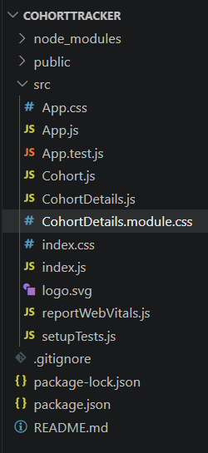

CohortDetails.js
import styles from "./CohortDetails.module.css";
function CohortDetails(props) {
return (
<div className={styles.box}>
<h3>
{props.cohort.cohortCode} -
<span className={styles.tech}>
{props.cohort.technology}
</span>
</h3>
<dl>
<dt>Started On</dt>
<dd>{props.cohort.startDate}</dd>
<dt>Current Status</dt>
<dd className={
props.cohort.currentStatus === "Scheduled"
? styles.scheduled
: styles.ongoing
}>
{props.cohort.currentStatus}
</dd>
<dt>Coach</dt>
<dd>{props.cohort.coachName}</dd>
<dt>Trainer</dt>
<dd>{props.cohort.trainerName}</dd>
</dl>
</div>
);
}
export default CohortDetails;

CohortDetails.module.css
.box{
border:2px solid gray;
padding:15px;
margin:15px;
border-radius:8px;
width:350px;
}
.tech{
color:blue;
font-weight:bold;
}
.scheduled{
color:blue;
font-weight:bold;
}
.ongoing{
color:green;
font-weight:bold;
}
dt{
font-weight:bold;
}
dd{
margin-bottom:10px;
}

App.js
import './App.css';
import { CohortsData } from './Cohort';
import CohortDetails from './CohortDetails';
function App() {
return (
<div>
<h1>Cohorts Details</h1>
{CohortsData.map(cohort => (
<CohortDetails cohort={cohort}/>
))}
</div>
);
}
export default App;

Output
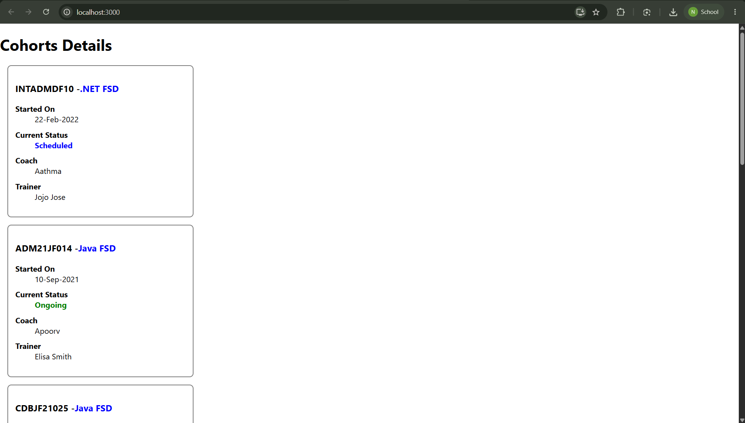
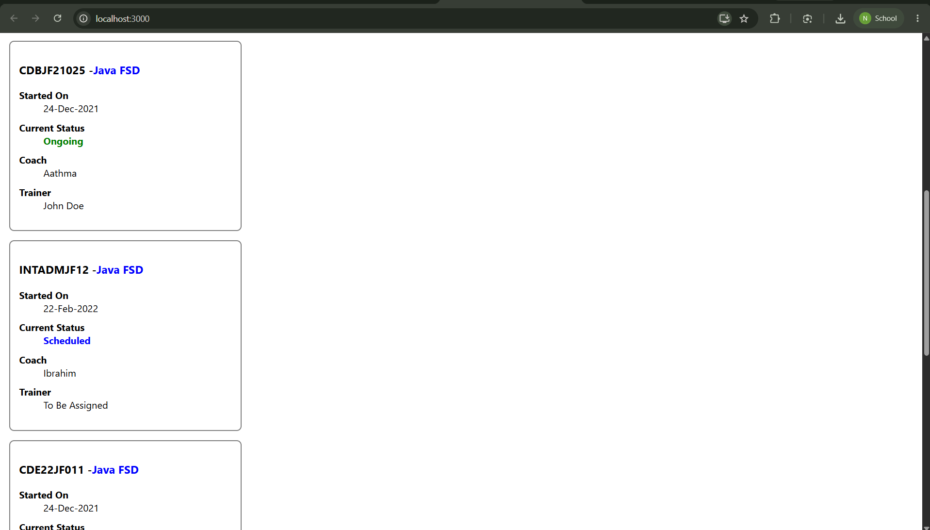
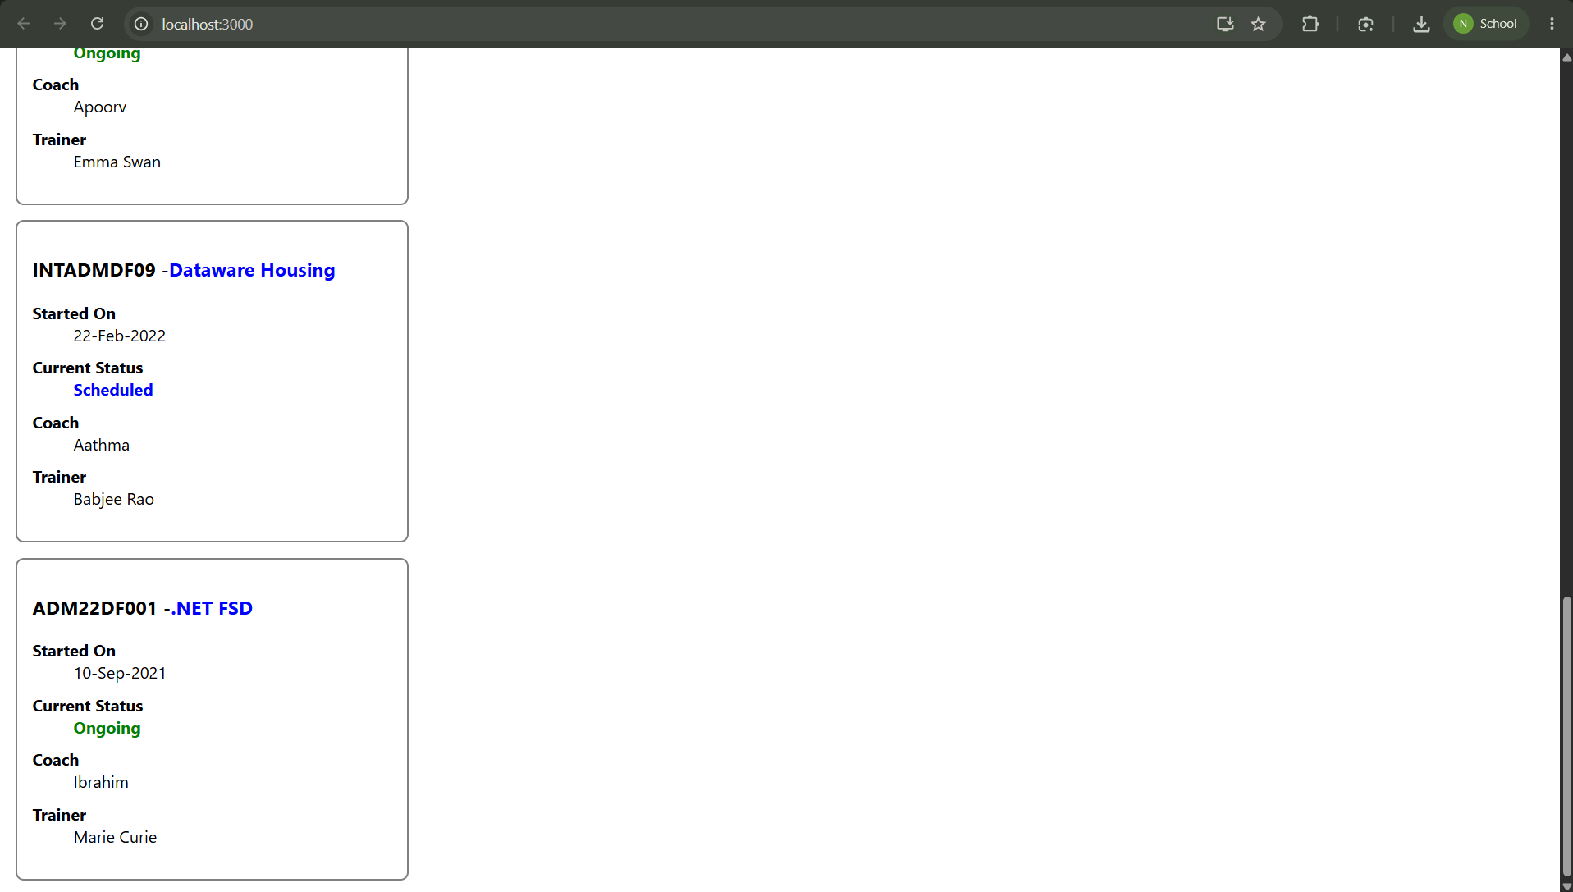

Result
The cohorttracker React application was successfully styled using CSS Modules. The cohort details were displayed with conditional formatting based on the cohort status.

